# CS 255 System Design Document Eaton

This template lays out all the different sections that you need to complete for Project Two. Each section has guidance to prompt your thinking. You will need to continually reference the interview transcript as you work to make sure that you are addressing your client’s needs. There is no required length for the final document. Instead the goal is to complete each section based on what your client’s needs are. Remove this note when you are finished, and replace all bracketed text with the relevant information.

## UML Diagrams

### UML Use Case Diagram

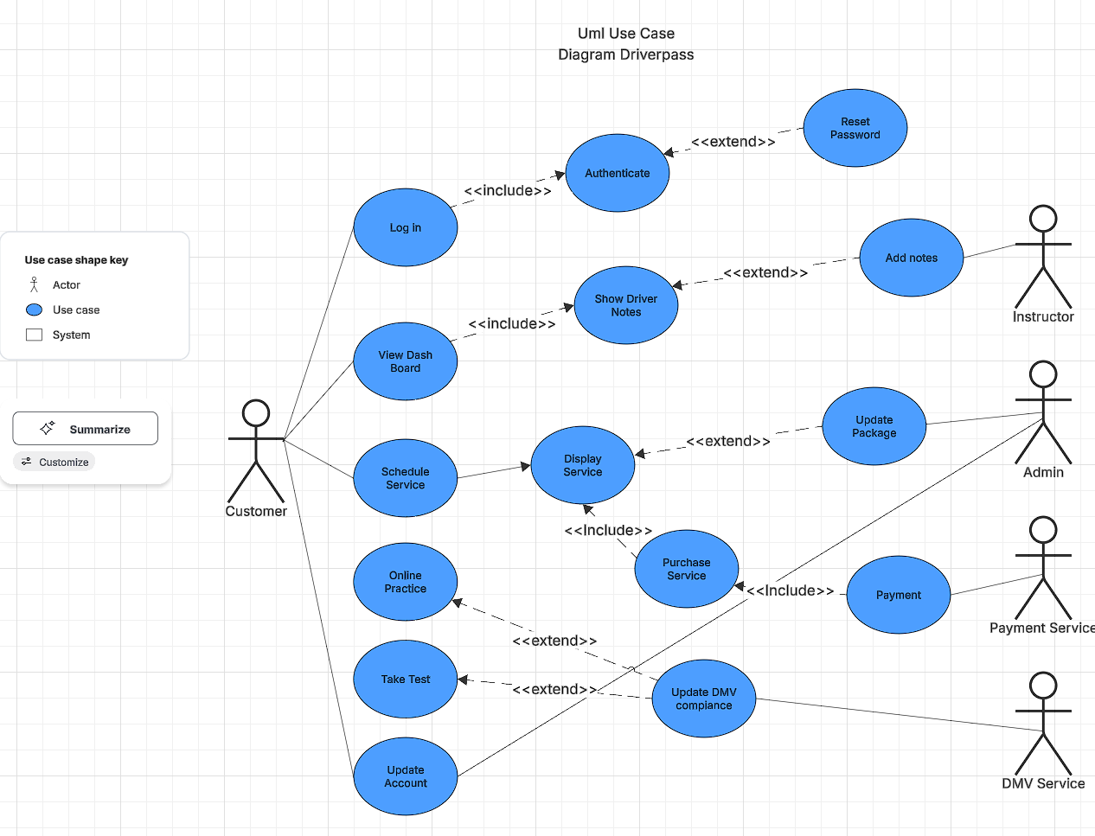

### UML Activity Diagrams

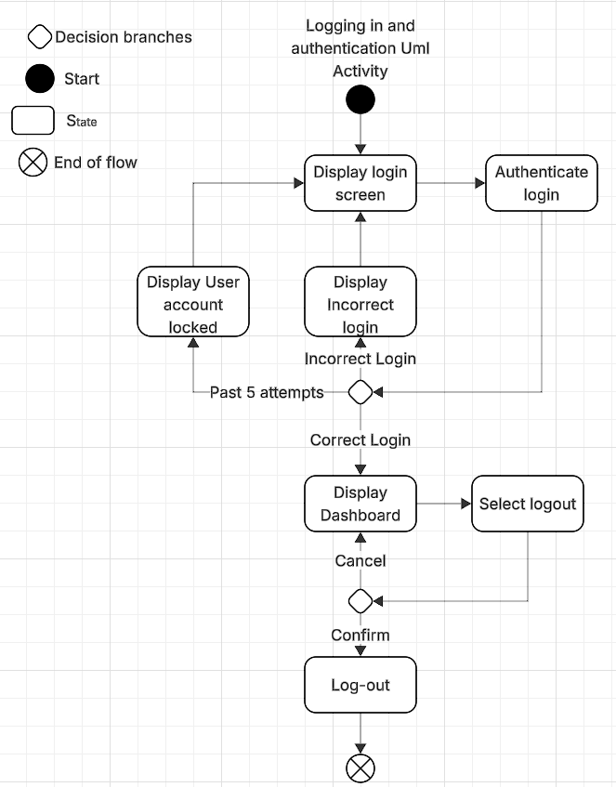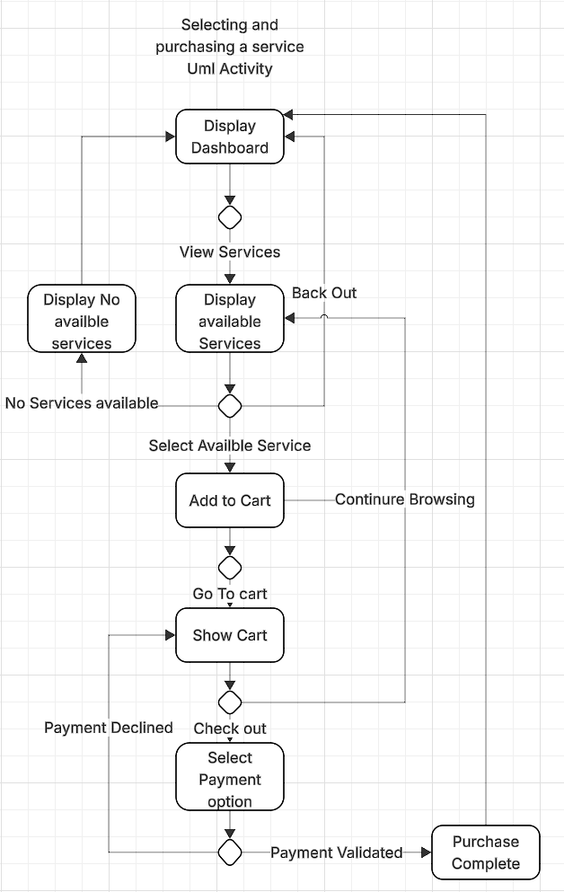

### UML Sequence Diagram

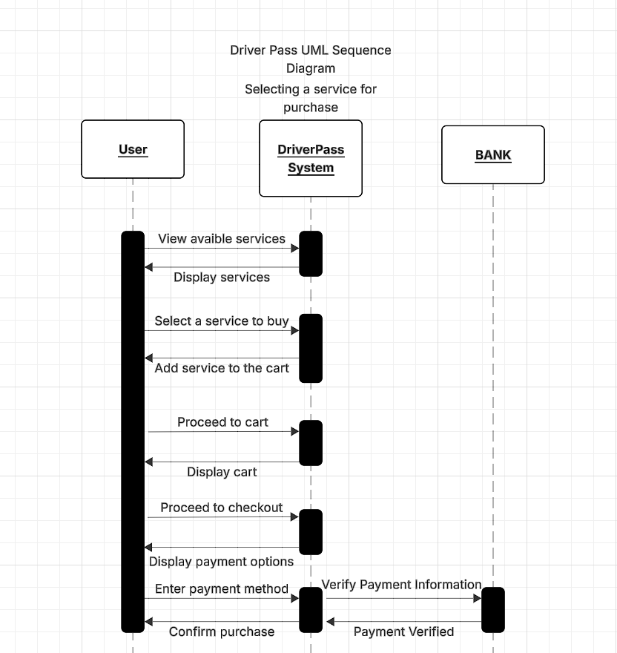

### UML Class Diagram

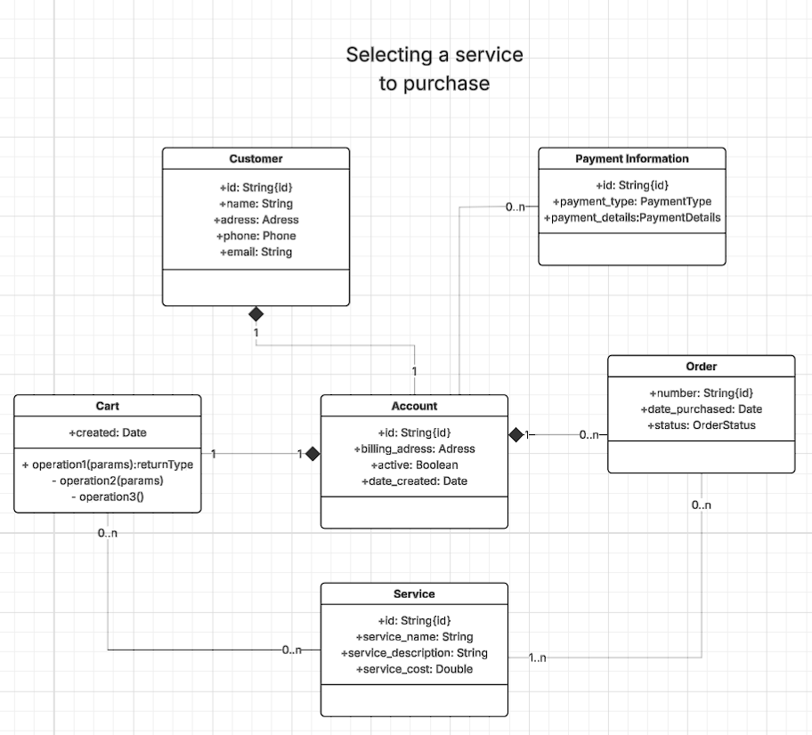

## Technical Requirements

*Looking at the diagrams above, the Driver Pass application will require a hosting service that will host the web app, while users access the application via different types of web browsers. The hosting service will benefit the most by being outsourced to a different third party that way Driver pass does not need to incorporate man hours into server maintenance and other technical work and can instead focus on the goal of getting drivers ready. A database is a requirement as we will need somewhere to store users' account information. Authentication will be required to protect sensitive data and detour brute force attacks into the system Driver Pass will also need to be able to incorporate a payment system into the web app to allow for payments to be sent and received for purchases of select services.*